**CSE 303: Data Communication**

**CT 1**

**Marks – 20 Time – 25 Minutes**

1. Let’s say we have a topology as follows.

Suppose the logical and physical addresses consist of 1 byte only (for only this example). Here every point is denoted here with

Logical address / physical address

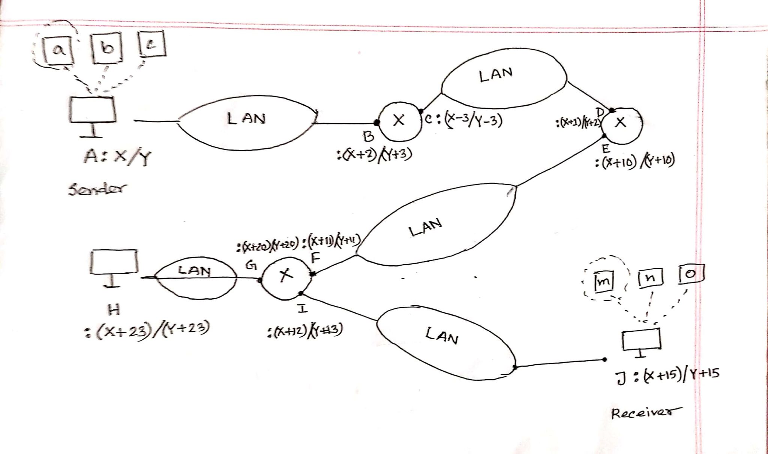

Here X means the last 3 digits of your roll.

For Example, if your roll is 14101102, X= 102.

And Y = 200 – X

For you convenience the IP and mac addresses at every point are given once again in the following chart:

|  |  |  |
| --- | --- | --- |
| Point | Logical Address | Physical Address |
| A | X | Y |
| B | X+2 | Y+3 |
| C | X-3 | Y-3 |
| D | X+1 | Y+2 |
| E | X+10 | Y+10 |
| F | X+11 | Y+11 |
| G | X+20 | Y+20 |
| H | X+23 | Y+23 |
| I | X+12 | Y+13 |
| J | X+15 | Y+15 |

Suppose Sender at A point, process ‘a’ (port address: 100) wants to send a data packet to J point, process ‘m’ (port address 105).

Your work is to show the different part values of data packets in all ten points in correct format. Mention the followings for every packet.

|  |  |  |  |  |  |  |
| --- | --- | --- | --- | --- | --- | --- |
| Receiver Mac | Sender Mac | Receiver  IP | Sender IP | Receiver Port | Sender Port | Data |

Solution:

Suppose, My ID is 14101102

X = 102

Y = 98

|  |  |  |  |  |  |  |  |
| --- | --- | --- | --- | --- | --- | --- | --- |
| Point | Sender MAC | Receiver MAC | Sender IP | Receiver IP | Sender process port | Receiver process port | Data |
| A | 98 | 101 | 102 | 117 | 100 | 105 | Data |
| B | 98 | 101 | 102 | 117 | 100 | 105 | Data |
| C | 95 | 100 | 102 | 117 | 100 | 105 | Data |
| D | 95 | 100 | 102 | 117 | 100 | 105 | Data |
| E | 108 | 109 | 102 | 117 | 100 | 105 | Data |
| F | 108 | 109 | 102 | 117 | 100 | 105 | Data |
| I | 111 | 113 | 102 | 117 | 100 | 105 | Data |
| J | 111 | 113 | 102 | 117 | 100 | 105 | Data |

G – Not visited

H – Not visited